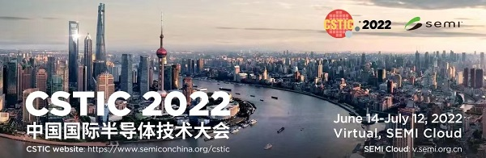
Thanks for registering China Semiconductor Technology International Conference(CSTIC) 2022. On behalf of Dr. Hanming Wu, CSTIC 2022 conference chair and organizing committees, we warmly welcome you to join our online event at Microsoft Teams meeting.

Microsoft Teams Meeting
Please use computer or mobile phone to join us
点击此处加入会议 Click here to join the meeting
Live Invited Speeches are also available from June 15 to 22, where you can communicate with invited speakers online directly. You can reserve the meeting at SEMI cloud and reminders and conference link will be sent to you one day before the live meeting. The following agenda might be updated in the next few days.
- Symposium I: June 15
9:00-9:30 Novel Thermal Material Properties for Post-CMOS Neuromorphic Computing, Dr. Suhas Kumar, Principal Scientist, Sandia National Lab
9:30-10:00 The Road to Compatible with and Beyond Silicon Circuits for 2D Materials, Prof. Peng Zhou, Fudan University
10:00-10:30 Enabling 3D Monolithic Integration using Oxide-Semiconductor-based Transistors, Prof.Xiao Gong, National University of Singapore
Symp II: June 16
9:00-9:30 Inverse lithography technology: 30 years from concept to practical, full-chip reality Dr. Leo Pang, Chief Product Officer, D2S, Inc
9:30-10:00 Advanced Lithography Material Status toward 5nm Node and beyond Dr. Koichi FUJIWARA, VP, JSR Shanghai Co., Ltd.
Symp IX: June 17
11:00-11:35 Interesting technical challenges in FPGA-based prototyping and emulation Dr. Pei-Hsin Ho, CTO, Shanghai UniVista Industrial Software Group
13:30-14:00 Polynomial Formal Verification of General Tree-like Circuits Dr. Alireza MAHZOON, University of Bremen
14:00-14:30 Agile Hardware Specialization for Spatial Architecture Prof. Yun LIANG, Peking University
14:30-15:00 Algorithm and architecture co-optimization for PIM-based DNN accelerators Prof. Li Jiang, Shanghai Jiaotong University
Symp IV: June 20
9:00-9:30 2D material and applications Prof. Zhihong Chen, Purdue University
9:30-10:00 Proliferation of ALD technology in the nano device era Dr. Jerry Chen, Global Product Marketing Manager, ASM
Symp VIII: June 21
9:30-10:00 Bio-inspired in-sensor vision adaptation for accurate perception, Prof. Yang CHAI, The Hong Kong Polytechnic University
10:00-10:30 Resonant piezoelectric MEMS sensors, Prof. Tianxiang NAN, Tsinghua University
Symp III: June 22
9:30-10:00 3D NAND Technology Cost Scaling Challenges and Solutions Dr. Richard Yang, CTO, Fortune Precision Corp

